E komo mai!
Welcome!
Tell me about you:

Today’s date: ___________ Last name_________________________________ First name _________________________________Middle Initial_____________

What do you prefer to be called? ______________________________________. Date of Birth____________________. Age __________. Gender: M / F

Street Address _____________________________________________________ City __________________________ State ___________ Zip Code ________

Home Telephone Number______________________________ Mobile Number________________________. Best time to reach you? ____________________

Email address: _____________________________________________________________________________________________________________________

Occupation _______________________________________________ Employer _______________________________________________________________

Employer Address ____________________________________________________ City_____________________ State _______________ Zip Code ________

Marital Status: _____________________. Spouses Name ___________________________________________________________________________________

In the event of an emergency, whom should we contact? ____________________________________________________________________________________

Relationship ______________________________. Best number where they could be reached ______________________________________________________

Name of your Primary Care Physician __________________________________ Office number ______________________ Fax number ____________________

Address: ______________________________________________________________ City ________________________ State _______________Zip ________
Do we have permission to release any findings or information related to your care in our office to your family doctor? Yes _________ No _____________

Whom may we thank for referring you to our office? ___________________________________________________ Relationship ________________________.

Reason for your visit…

The reason for today’s visit is a result of: Trauma _____. Chronic _____ Sports Injury _____ Work injury______ Auto Accident ______ Wellness Care ______

When did this condition begin? ____________________. Please describe the pain and its location: _________________________________________________

Explain what happened ______________________________________________________________________________________________________________

Is this condition getting worse? Yes ____ No ____ Constant _____ Comes and goes _____

Is this condition interfering with: Work ________ School ______ Sleep ______ Daily Routine? Please explain _________________________________________

Have you had this or a similar condition in the past? Yes _____ No ____If yes, please explain ______________________________________________________

Has a Medical Physician treated you for this condition? Yes ____ No___ If yes, name and location____________________________________________________

Please briefly explain the treatment you received ____________________________________________________________________________________________

Has a Chiropractic Doctor treated you for this condition? Yes ____ No ____ If yes, name and location: ________________________________________________

Please briefly explain the treatment you received ___________________________________________________________________________________________

_________________________________________________________________________________________________________________________________

IMUA
4163 Waipua Street, Kilauea, HI 96754/Clinic 808.634-0450
Dr. Denise Walther, Chiropractor

Show me where you are hurting…

Describe your present condition: ________________________________________________________________________

Please mark the body area (s) of injury/pain/discomfort by using the appropriate symbols indicated below.

Numbness Aching Stabbing Burning Pins and Needles
N A S B P

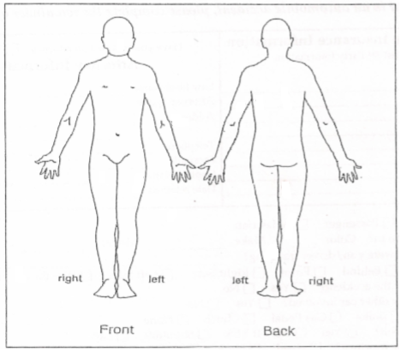
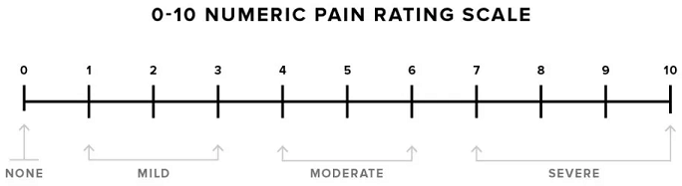

IMUA
4163 Waipua Street, Kilauea, HI 96754/Clinic 808.634-0450
Dr. Denise Walther, Chiropractor
Health History:

Are you taking any of the following medication (s)?
Pain Killers _____ Muscle Relaxers _____ Stimulants _____ Blood Thinners _____ Tranquilizers _____ Insulin _____ Anti-inflammatory _____

Other _________________________________________________________________________________________________________________

Do you currently have or have you ever had any of the following diseases/ medical condition (s)? (Please check to the left to all that applies)

 | Heart Attack/ Stroke |  | Diabetes |  | Lower Back Problems |  | Stomach Problems
 | Congenital Heart Defect |  | Cancer / Chemotherapy |  | Prosthetic devices/ joints |  | Headaches
 | High / Low Blood Pressure |  | Shingles |  | Hepatitis |  | Liver Problems
 | Frequent Neck Pain |  | Emphysema |  | Anemia Rheumatic Fever |  | Eye Problems
 | Fainting/ Seizures/ Epilepsy |  | Kidney Problems |  | Ulcers/ Colitis |  | Hearing
 | Heart Surgery / Pacemaker |  | Alcohol/ Drug Abuse |  | Tuberculosis |  | Scoliosis
 | Mitral Valve Prolapse |  | Sinus Problems |  | Arthritis |  | Gallbladder
 | Difficulty Breathing |  | HIV+ / AIDS |  | Psychiatric disorders |  | Broken bones

Please List any other serious medical condition (s) you have or ever had_____________________________________________________________________

Please list anything that you may be allergic to ___________________________________________________________________________________________

Please list previous surgeries with date ___ ______________________________________________________________________________________________

Please list any past serious accidents with date ___________________________________________________________________________________________

Do you smoke? Yes ____ No ____ How long? ___________________________________________________ How much daily? ________________________

Are you wearing: Heel Lifts _____ Arch Supports _____ Sole Supports ______ Inner Soles _______?

What do you sleep on? How old is your mattress ________. What kind? _____________. Is it comfortable? ________ Do you wake up refreshed? ______

Do you sleep primarily on your side/ back/ stomach? ___________________What kind of neck support (pillow) do you use? _________________________

How many hours do you sleep? ____ Do you nap during the day and for how long _________________________

How many hours do you SIT daily? ____ . How many hours are you in front of the computer daily? ___________________________.

Describe your typical daily activities? _________________________________________________________________________________________________________________________________

Is there anything else you wish to discuss?

Mahalo! I look forward to our time together.

Denise

IMUA
(ee-mooh-ah) Moving forward with Strength, Courage and Strong Spirit

